**Assignment No: 6**

**Sentiment Analysis Using LSTM Network or GRU**

**Problem Statement:**

To implement a sentiment analysis system that classifies text (e.g., reviews) as positive, negative, or neutral using LSTM or GRU networks.

**Objective:**

1. **To understand the architecture and working of LSTM and GRU networks.**
2. **To preprocess textual data for training deep learning models.**
3. **To evaluate the performance of the sentiment analysis model.**

**S/W Packages and H/W Apparatus Used:**

* **Operating System:** Windows/Linux/MacOS
* **Kernel:** Python 3.x
* **Tools:** Jupyter Notebook, Anaconda, or Google Colab
* **Hardware:** CPU with minimum 4GB RAM; optional GPU for faster training

**Libraries and Packages Used:**

* **TensorFlow/Keras:** Frameworks for building and training deep learning models.
* **NumPy:** Library for numerical computations and array manipulations.
* **Pandas:** Library for data manipulation and analysis.
* **Scikit-Learn:** Useful for splitting datasets and evaluation metrics.
* **Matplotlib/Seaborn:** Libraries for data visualization.

**Theory:**

1. **LSTM (Long Short-Term Memory):**
   * A type of recurrent neural network (RNN) designed to overcome the limitations of traditional RNNs by effectively learning long-term dependencies. LSTMs utilize memory cells and gating mechanisms to control the flow of information, enabling them to retain information over extended sequences.
2. **GRU (Gated Recurrent Unit):**
   * A simpler alternative to LSTM, GRUs use fewer gates and parameters while still performing comparably in many tasks. They combine the cell state and hidden state, streamlining computations and making them faster and easier to implement.
3. **Working of LSTM** –   
   Long Short-Term Memory (LSTM) networks are a type of recurrent neural network (RNN) that can learn and retain long-term dependencies in sequential data. LSTM is especially well-suited for tasks involving time series, speech, and text, such as sentiment analysis, where the order and context of data are crucial.
   1. **Understanding LSTM**
      * LSTM networks were designed to address the limitations of traditional RNNs, which struggle with learning long-term dependencies due to the "vanishing gradient" problem.
      * LSTM introduces a memory cell along with three gates: the **input gate**, **forget gate**, and **output gate**, which help control the flow of information. These gates help the network decide which information to keep or discard
   2. **LSTM Architecture**
      * **Memory Cell:** Acts as the cell state, retaining relevant information across time steps.
      * **Forget Gate:** Determines what portion of the previous information should be forgotten.
      * **Input Gate:** Decides what new information should be added to the memory cell.
      * **Output Gate:** Controls what information is output from the cell state at a particular time step.
   3. **LSTM in Sentiment Analysis**
      * In sentiment analysis, the goal is to classify text data (e.g., reviews, tweets) as expressing a particular sentiment, such as positive, negative, or neutral.
      * LSTM networks are effective for this task because they can capture the context of words across a sequence, maintaining an understanding of how earlier words influence later ones in a sentence.
      * For example, in the sentence "The movie was not very good," the word "not" significantly changes the sentiment of the word "good." LSTM can remember the negation and correctly classify the sentiment.

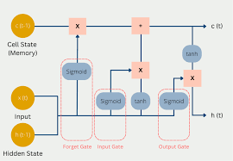

(Fig.1 Architecture diagram of LSTM)

* **Methodology:**
  1. **Data Acquisition:**
     + Load a dataset of text reviews (e.g., IMDB dataset) containing sentiment labels.
  2. **Data Preparation:**
     + Preprocess text data through tokenization, padding to ensure uniform input length, and vectorization for compatibility with neural networks.
  3. **Model Architecture:**
     + Create an LSTM or GRU model incorporating embedding, recurrent, and dense layers to effectively learn from the sequential data.
  4. **Model Compilation:**
     + Compile the model using an appropriate optimizer (like Adam) and loss function (e.g., binary cross-entropy for binary sentiment classification).
  5. **Model Training:**
     + Fit the model on the training data while validating performance using a separate validation set to monitor overfitting.
  6. **Model Evaluation:**
     + Evaluate the model’s performance using metrics such as accuracy, precision, recall, and F1-score to ensure reliable sentiment classification.
  7. **Display Results:**
     + Plot the training and validation loss and accuracy over epochs to visualize model performance and improvements.

**Working Algorithm:**

1. **Import Libraries:**
   * Import necessary libraries: TensorFlow/Keras, NumPy, Pandas, Scikit-Learn, Matplotlib/Seaborn.
2. **Load the Dataset:**
   * Read the dataset containing text reviews and their sentiment labels (e.g., using pd.read_csv()).
3. **Data Preprocessing:**
   * Clean the text data (remove special characters, convert to lowercase, etc.).
   * Tokenize the text data using Tokenizer() from Keras.
   * Pad sequences to ensure uniform input length using pad_sequences().
   * Split the dataset into training and validation sets (e.g., using train_test_split() from Scikit-Learn).
4. **Build the Model:**
   * Create an LSTM or GRU model using Keras.
   * Add an embedding layer, recurrent layer (LSTM/GRU), and dense layer for output.
5. **Compile the Model:**
   * Use an appropriate optimizer (e.g., Adam) and loss function (e.g., binary crossentropy).
6. **Train the Model:**
   * Fit the model on the training data, using validation data to monitor performance (model.fit()).
7. **Evaluate the Model:**
   * Measure accuracy, precision, recall, and F1-score on the validation set using Scikit-Learn metrics.
8. **Display Results:**
   * Plot the training and validation loss and accuracy over epochs using Matplotlib/Seaborn.

**Advantages:**

* **Contextual Understanding:** LSTM and GRU networks excel in capturing context and dependencies in text data, enabling them to understand nuances in sentiment.
* **Effective for Sequential Data:** These architectures are specifically designed for sequential data, making them ideal for tasks involving time-series or text sequences.

**Limitations:**

* **Data Requirements:** LSTM and GRU models require a substantial amount of labeled data for training to achieve optimal performance.
* **Computational Cost:** Training these models can be computationally expensive, especially with large datasets, and may require access to GPUs for efficient processing.

**Disadvantages:**

* **Complexity of Tuning:** Hyperparameter tuning can be complex and time-consuming, as various parameters significantly influence model performance.
* **Overfitting Risk:** Deep learning models may overfit the training data if not properly regularized or validated, leading to poor generalization on unseen data.
* **Lack of Interpretability:** Unlike traditional machine learning models, deep learning models like LSTM and GRU can be seen as "black boxes," making it challenging to interpret their decisions and understand why certain classifications are made.

**Applications:**

* **Analyzing Customer Feedback:** Businesses can leverage sentiment analysis to gauge customer opinions and improve their products or services based on feedback.
* **Social Media Sentiment Monitoring:** Organizations can track sentiment on social media platforms to understand public perception and react accordingly.
* **Opinion Mining:** Extracting sentiments from various text sources, such as news articles, blogs, or product reviews, to assess public opinion on topics or events.

**Working Algorithm:**

1. **Import Libraries:**
   * Import TensorFlow/Keras, NumPy, and other necessary libraries.
2. **Load the Dataset:**
   * Read the dataset containing text reviews and their sentiment labels.
3. **Data Preprocessing:**
   * Tokenize the text data.
   * Pad sequences to ensure uniform input length.
   * Split the dataset into training and validation sets.
4. **Build the Model:**
   * Create an LSTM or GRU model using Keras.
   * Add embedding, recurrent, and dense layers.
5. **Compile the Model:**
   * Use an appropriate optimizer (e.g., Adam) and loss function (e.g., binary cross-entropy).
6. **Train the Model:**
   * Fit the model on the training data, using validation data to monitor performance.
7. **Evaluate the Model:**
   * Measure accuracy, precision, recall, and F1-score on the validation set.
8. **Display Results:**
   * Plot the training and validation loss and accuracy over epochs.

**Diagram:**

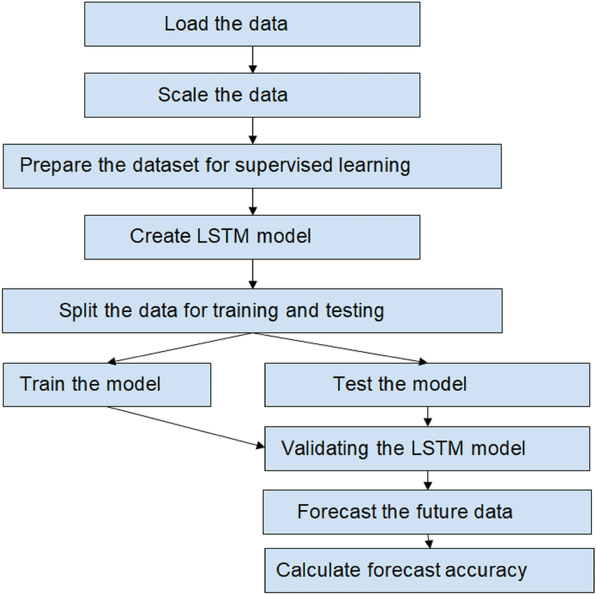

(Fig.2 Flow of Sentiment Analysis)

**Conclusion:**

Implementing sentiment analysis using LSTM or GRU networks effectively captures the nuances of textual data, enabling accurate classification of sentiments as positive, negative, or neutral. The use of deep learning models provides significant advantages over traditional methods, particularly in handling sequential data and understanding contextual relationships.

While the model's performance is heavily reliant on the quality and quantity of training data, careful preprocessing and tuning can lead to high accuracy and generalization, making it a valuable tool for applications in customer feedback analysis, social media monitoring, and opinion mining. As advancements in deep learning continue, the potential for sentiment analysis systems to provide deeper insights and more refined classifications will only grow, paving the way for enhanced decision-making in various industries.